Application
Clone the below mentioned repository and deploy the application (Run application in port 3000).
Repo URL : https://github.com/Vennilavan12/Trend.git
Cloned git repo into local
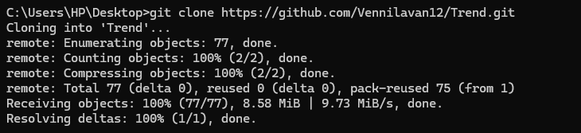
Created new git repo and pushed the required file into the repo
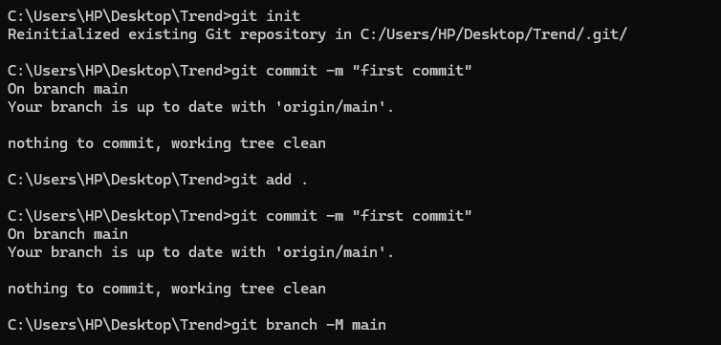
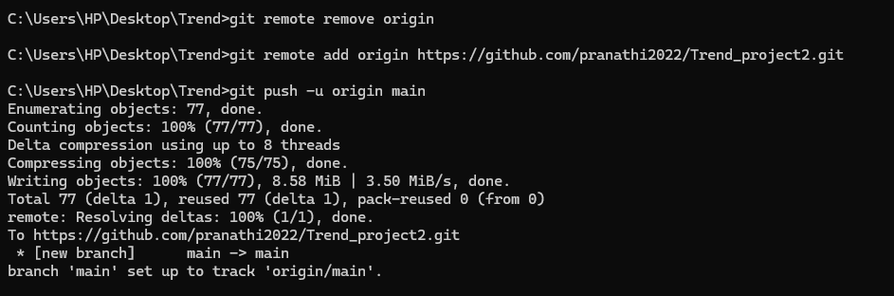

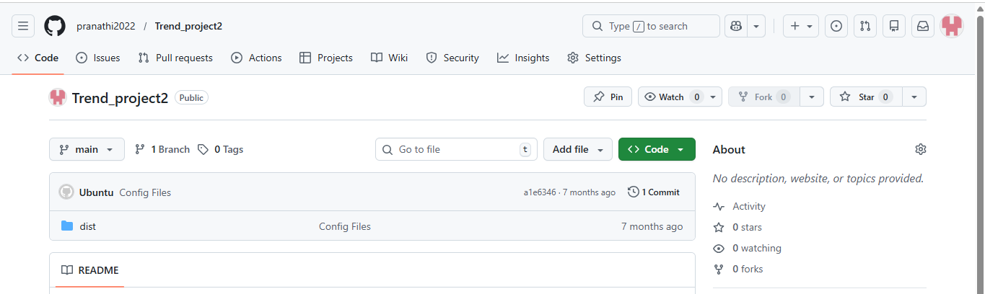
Dockerfile
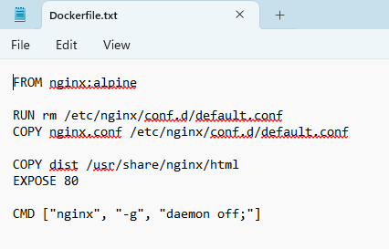
Configuration file - Nginx.conf
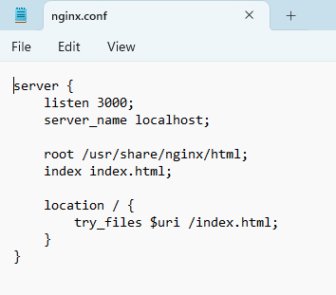
Pushing the dockerfile and conf file into github

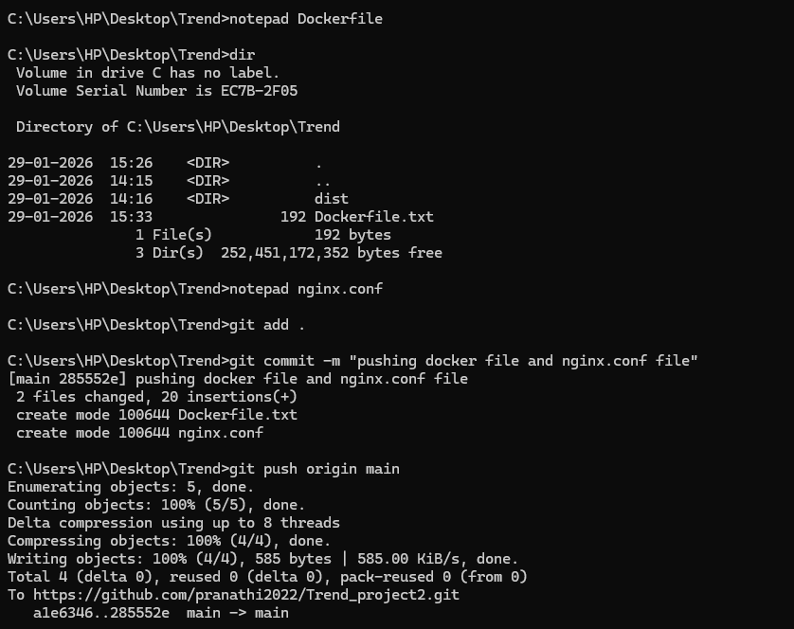
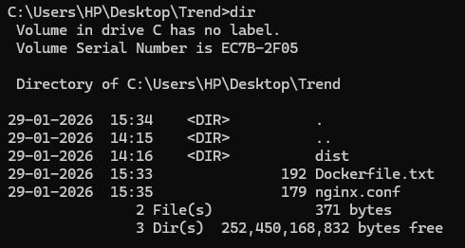
docker build -t trend:latest .
docker run -d -p 3000:3000 --name trend trend:latest
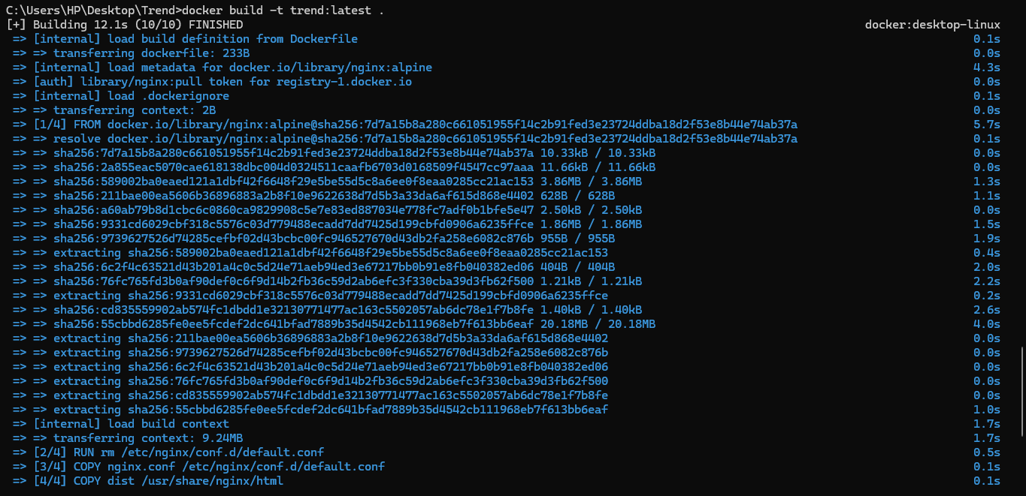
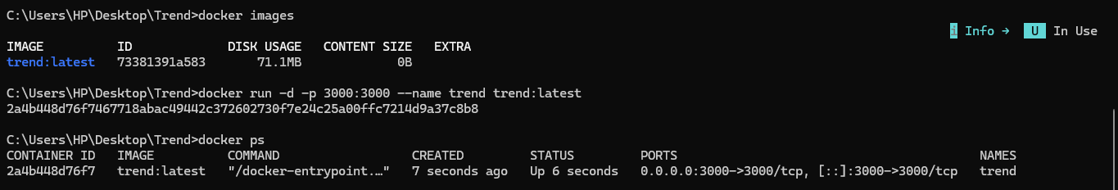
Application is running on port 3000

Created a repo on dockerhub

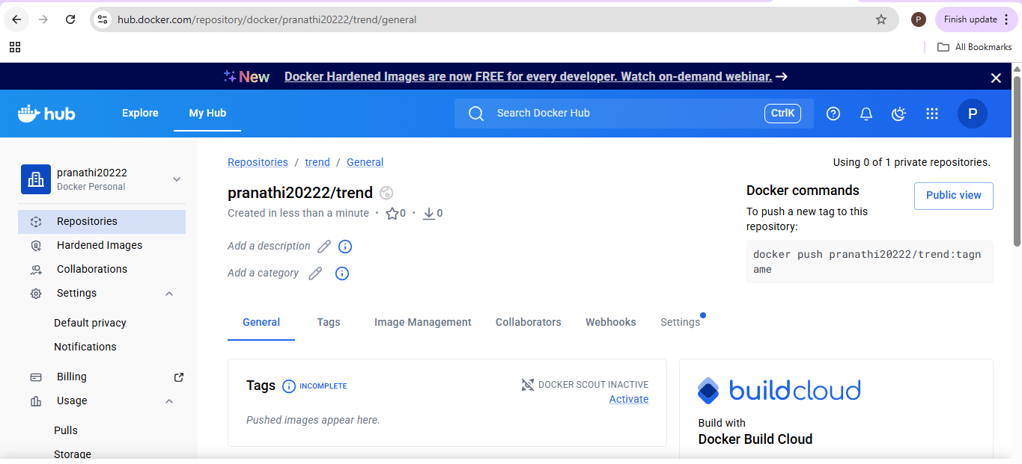
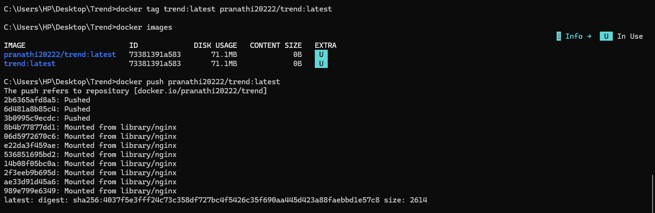
Pushed the build image on dockerhub
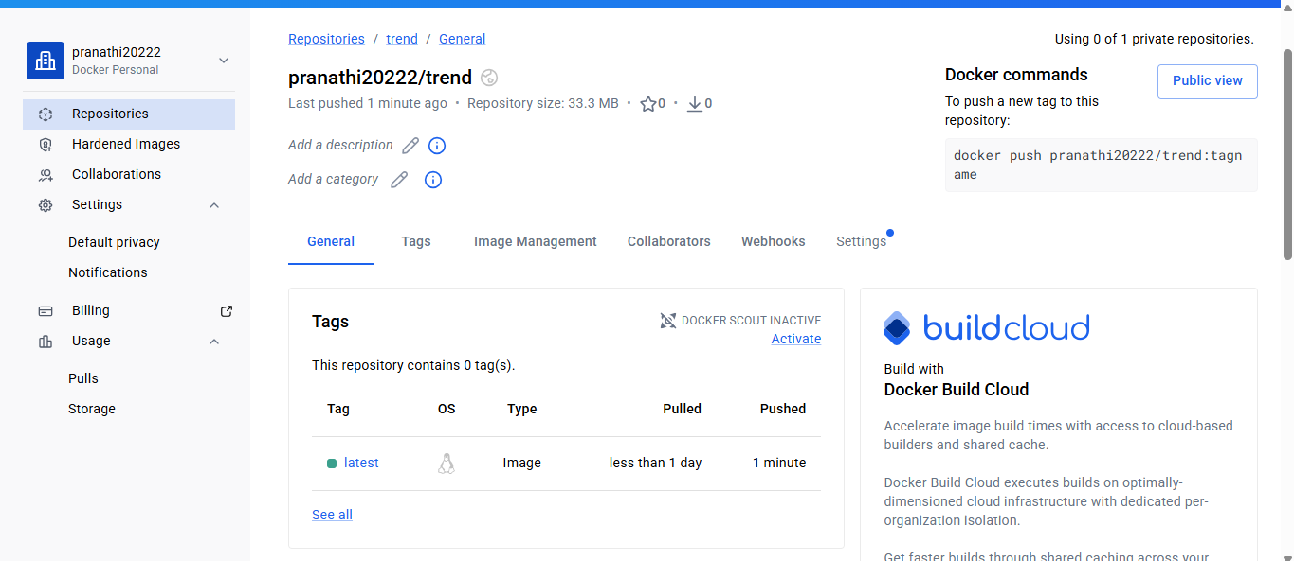
Testing .Dockerignored
Ignored .git & Dockerfile
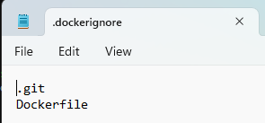
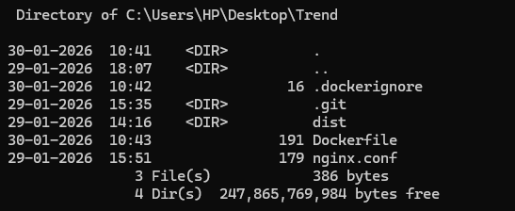
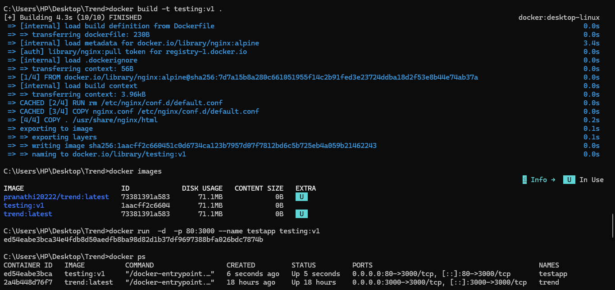
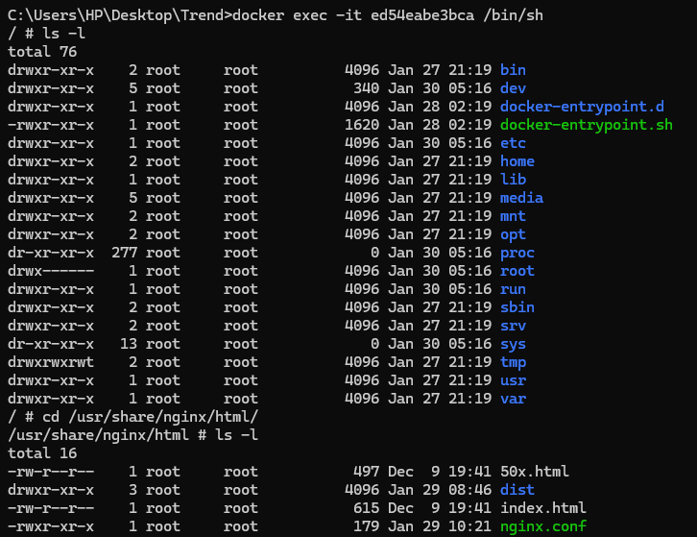
After entering into docker, checking the ignored files
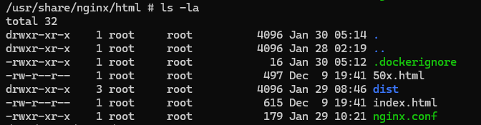
Terraform
main.tf
provider "aws" {
region = "ap-south-1"
}

# ---------------------------
# VPC
# ---------------------------
resource "aws_vpc" "trend_vpc" {
cidr_block = "10.0.0.0/16"

tags = {
Name = "trend-vpc"
}
}

# ---------------------------
# Public Subnet 1 (AZ-1a)
# ---------------------------
resource "aws_subnet" "trend_subnet_1" {
vpc_id = aws_vpc.trend_vpc.id
cidr_block = "10.0.1.0/24"
availability_zone = "ap-south-1a"
map_public_ip_on_launch = true

tags = {
Name = "trend-public-subnet-1a"
"kubernetes.io/cluster/trend-eks" = "shared"
"kubernetes.io/role/elb" = "1"
}
}

# ---------------------------
# Public Subnet 2 (AZ-1b)
# ---------------------------
resource "aws_subnet" "trend_subnet_2" {
vpc_id = aws_vpc.trend_vpc.id
cidr_block = "10.0.2.0/24"
availability_zone = "ap-south-1b"
map_public_ip_on_launch = true

tags = {
Name = "trend-public-subnet-1b"
"kubernetes.io/cluster/trend-eks" = "shared"
"kubernetes.io/role/elb" = "1"
}
}

# ---------------------------
# Internet Gateway
# ---------------------------
resource "aws_internet_gateway" "trend_igw" {
vpc_id = aws_vpc.trend_vpc.id

tags = {
Name = "trend-igw"
}
}

# ---------------------------
# Route Table
# ---------------------------
resource "aws_route_table" "trend_rt" {
vpc_id = aws_vpc.trend_vpc.id

route {
cidr_block = "0.0.0.0/0"
gateway_id = aws_internet_gateway.trend_igw.id
}

tags = {
Name = "trend-public-rt"
}
}

# ---------------------------
# Route Table Associations
# ---------------------------
resource "aws_route_table_association" "trend_rta_1" {
subnet_id = aws_subnet.trend_subnet_1.id
route_table_id = aws_route_table.trend_rt.id
}

resource "aws_route_table_association" "trend_rta_2" {
subnet_id = aws_subnet.trend_subnet_2.id
route_table_id = aws_route_table.trend_rt.id
}

# ---------------------------
# Security Group (Jenkins ONLY)
# ---------------------------
resource "aws_security_group" "jenkins_sg" {
name = "jenkins-sg"
vpc_id = aws_vpc.trend_vpc.id

ingress {
from_port = 22
to_port = 22
protocol = "tcp"
cidr_blocks = ["0.0.0.0/0"]
}

ingress {
from_port = 8080
to_port = 8080
protocol = "tcp"
cidr_blocks = ["0.0.0.0/0"]
}

egress {
from_port = 0
to_port = 0
protocol = "-1"
cidr_blocks = ["0.0.0.0/0"]
}

tags = {
Name = "jenkins-sg"
}
}

# ---------------------------
# Security Group (EKS Worker Nodes) ✅ NEW
# ---------------------------
resource "aws_security_group" "eks_nodes_sg" {
name = "eks-nodes-sg"
description = "Security group for EKS worker nodes"
vpc_id = aws_vpc.trend_vpc.id

# Kubernetes API Server
ingress {
from_port = 443
to_port = 443
protocol = "tcp"
cidr_blocks = ["0.0.0.0/0"]
}

# Kubelet
ingress {
from_port = 10250
to_port = 10250
protocol = "tcp"
cidr_blocks = ["0.0.0.0/0"]
}

# NodePort services
ingress {
from_port = 30000
to_port = 32767
protocol = "tcp"
cidr_blocks = ["0.0.0.0/0"]
}

# Node-to-node communication
ingress {
from_port = 0
to_port = 0
protocol = "-1"
self = true
}

# Outbound
egress {
from_port = 0
to_port = 0
protocol = "-1"
cidr_blocks = ["0.0.0.0/0"]
}

tags = {
Name = "eks-nodes-sg"
}
}

# ---------------------------
# IAM Role for Jenkins EC2
# ---------------------------
resource "aws_iam_role" "jenkins_role" {
name = "jenkins-role"

assume_role_policy = jsonencode({
Version = "2012-10-17"
Statement = [{
Effect = "Allow"
Principal = {
Service = "ec2.amazonaws.com"
}
Action = "sts:AssumeRole"
}]
})
}

resource "aws_iam_instance_profile" "jenkins_profile" {
name = "jenkins-instance-profile"
role = aws_iam_role.jenkins_role.name
}

# ---------------------------
# EC2 Instance (Jenkins)
# ---------------------------
resource "aws_instance" "jenkins" {
ami = "ami-0ff5003538b60d5ec"
instance_type = "t2.medium"
subnet_id = aws_subnet.trend_subnet_1.id
vpc_security_group_ids = [aws_security_group.jenkins_sg.id]
iam_instance_profile = aws_iam_instance_profile.jenkins_profile.name

user_data = <<-EOF
#!/bin/bash
yum update -y
wget -O /etc/yum.repos.d/jenkins.repo https://pkg.jenkins.io/redhat-stable/jenkins.repo
rpm --import https://pkg.jenkins.io/redhat-stable/jenkins.io.key
yum install java-17-amazon-corretto jenkins -y
systemctl start jenkins
systemctl enable jenkins
EOF

tags = {
Name = "Jenkins-EC2"
}
}
Executing terraform commands
Terraform init
Terraform validate
Terraform plan
Terraform apply
Using main.tf file created EC2,VPC,Subnet,route tables, Internet gateway
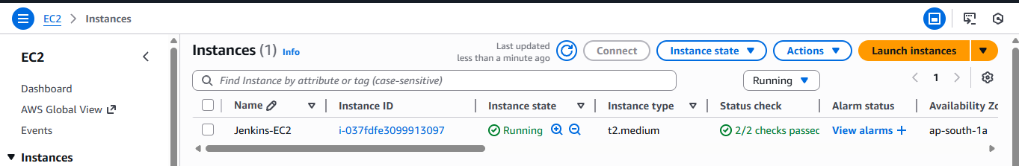
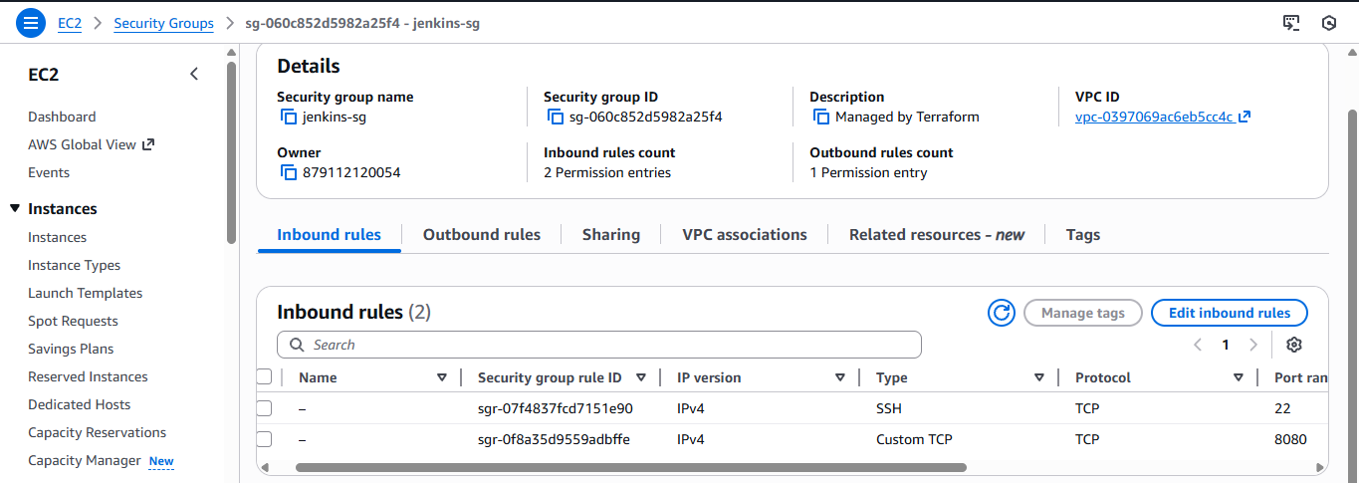
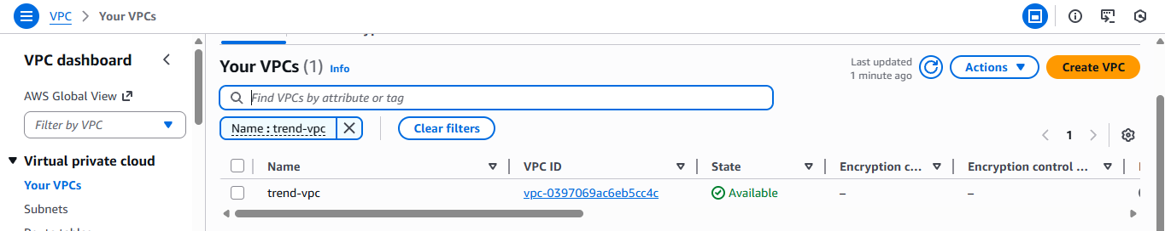
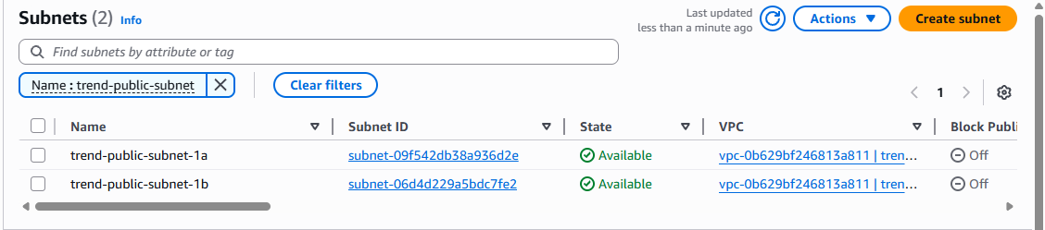
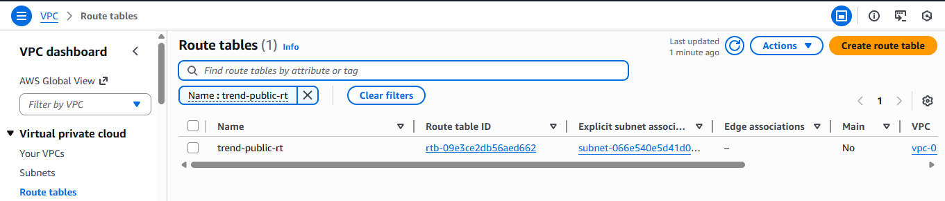
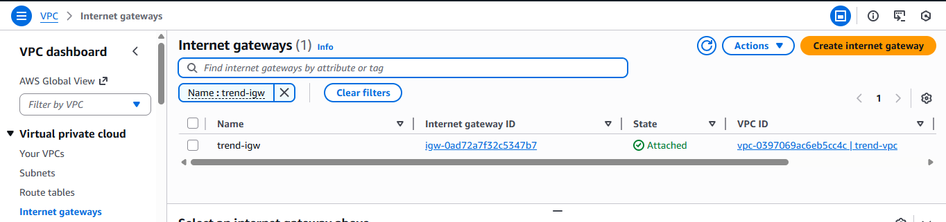
Terraform = VPC + Jenkins
eksctl = EKS cluster using same VPC
Installed Java & Jenkins
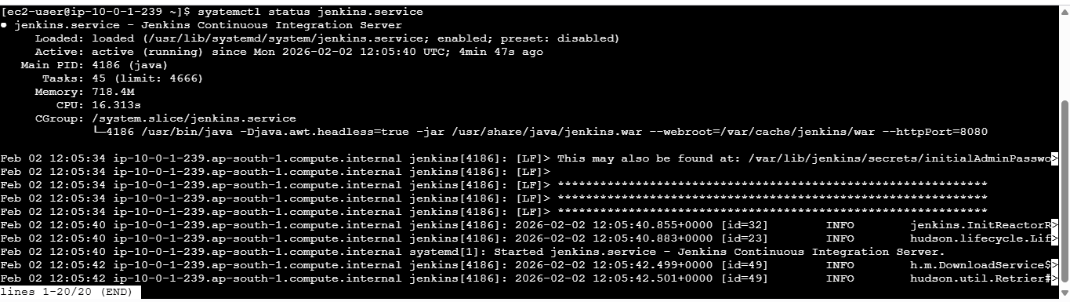
Terraform state file got created
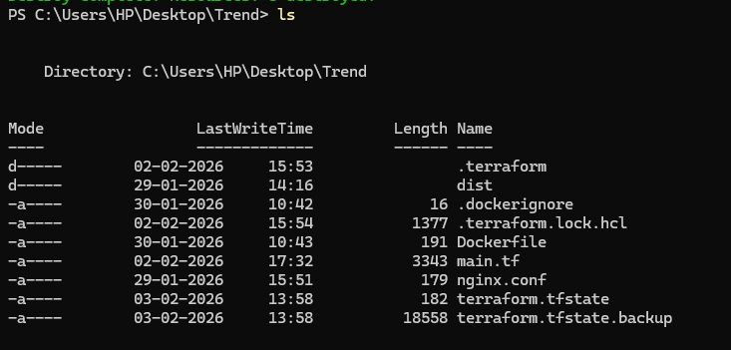
Terraform destroy
EKS
Deployment.yaml
apiVersion: apps/v1
kind: Deployment
metadata:
name: trend-app
spec:
replicas: 2
selector:
matchLabels:
app: trend
template:
metadata:
labels:
app: trend
spec:
containers:
- name: trend-container
image: pranathi20222/trend:latest
ports:
- containerPort: 3000

Service.yaml
apiVersion: v1
kind: Service
metadata:
name: trend-service
spec:
type: LoadBalancer
selector:
app: trend
ports:
- port: 80
targetPort: 3000

Created EKS-cluster.yaml file because wanted to use the custom vpc and subnets not the default one
Eks-cluster.yaml
apiVersion: eksctl.io/v1alpha5
kind: ClusterConfig

metadata:
name: trend-eks
region: ap-south-1

vpc:
id: vpc-0b629bf246813a811
subnets:
public:
ap-south-1a:
id: subnet-09f542db38a936d2e
ap-south-1b:
id: subnet-06d4d229a5bdc7fe2

nodeGroups:
- name: trend-nodes
instanceType: t2.medium
desiredCapacity: 2
minSize: 1
maxSize: 3
eksctl create cluster -f eks-cluster.yaml
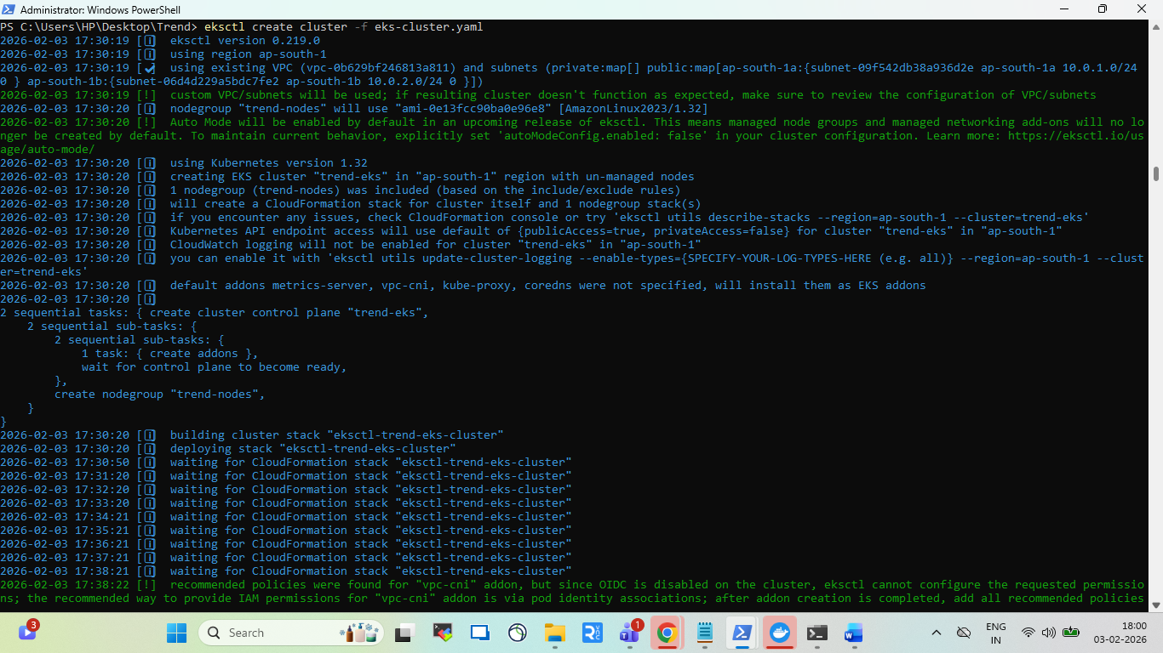
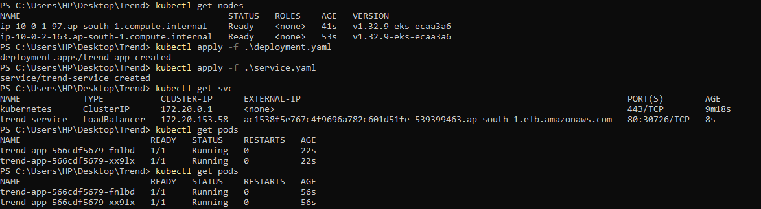
Created EKS cluster
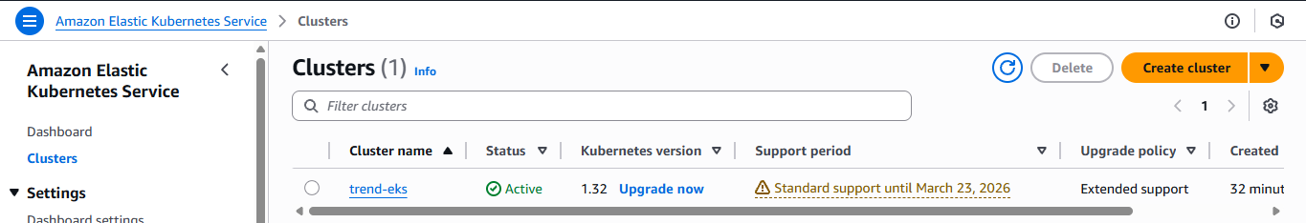
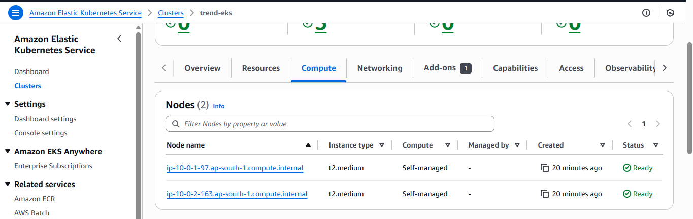
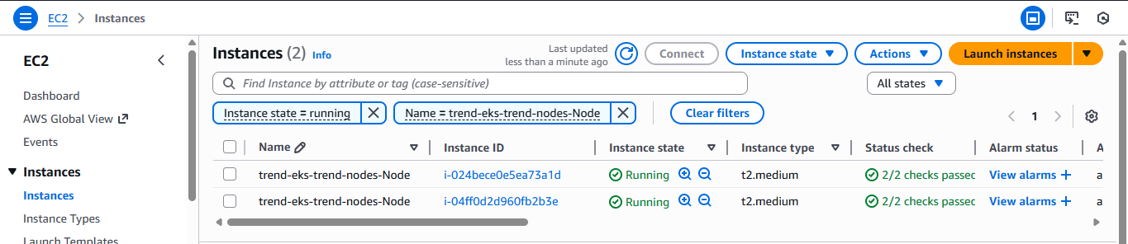

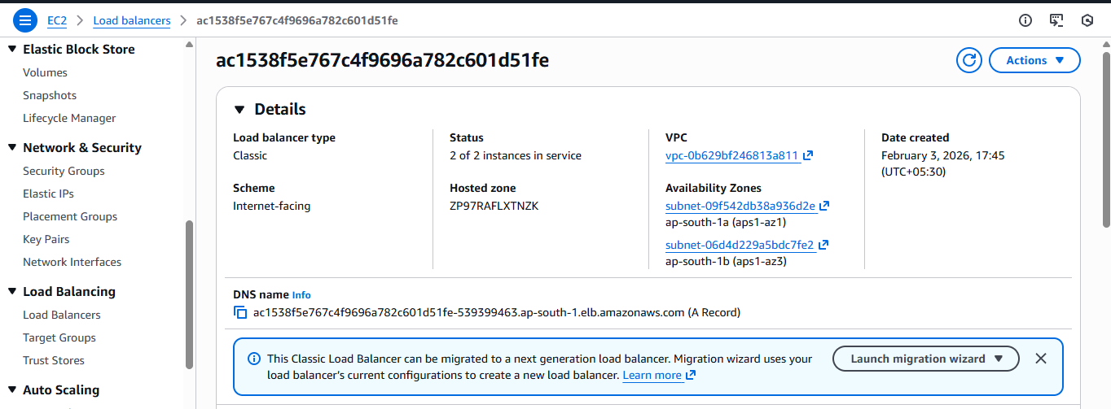
External-IP --- ac1538f5e767c4f9696a782c601d51fe-539399463.ap-south-1.elb.amazonaws.com
Kubernetes Service type LoadBalancer created an AWS Classic ELB automatically.
Classic ELB does not provide ARN like ELBv2.
LoadBalancer DNS and Name are:
- LoadBalancer DNS: aa2ed1501b4db446095a61f5e5b6b6ed-1254122273.ap-south-1.elb.amazonaws.com
- LoadBalancer Name: aa2ed1501b4db446095a61f5e5b6b6ed
Able to view application using load balancer

Jenkins
Installed Jenkins and running on port 8080
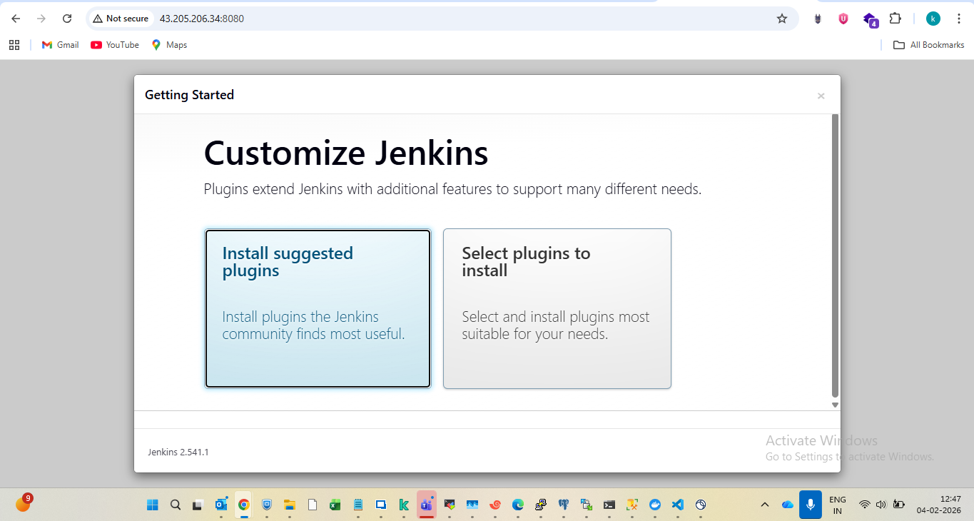
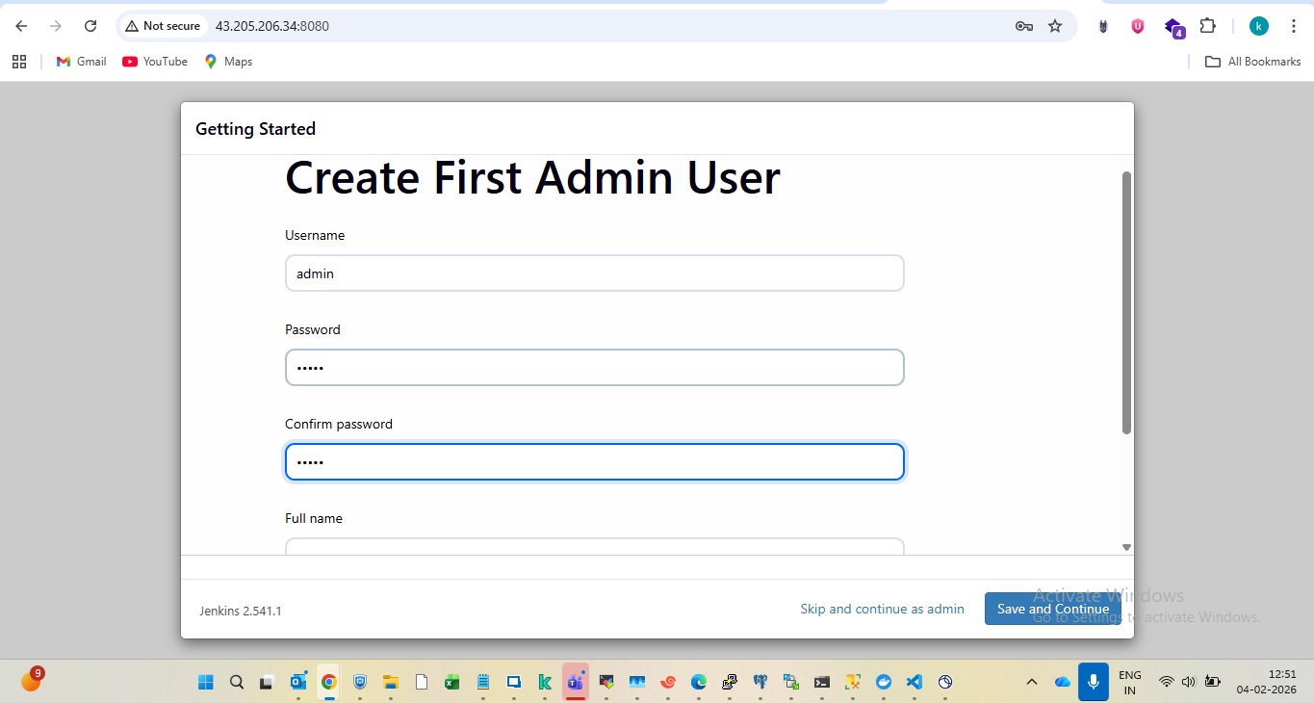
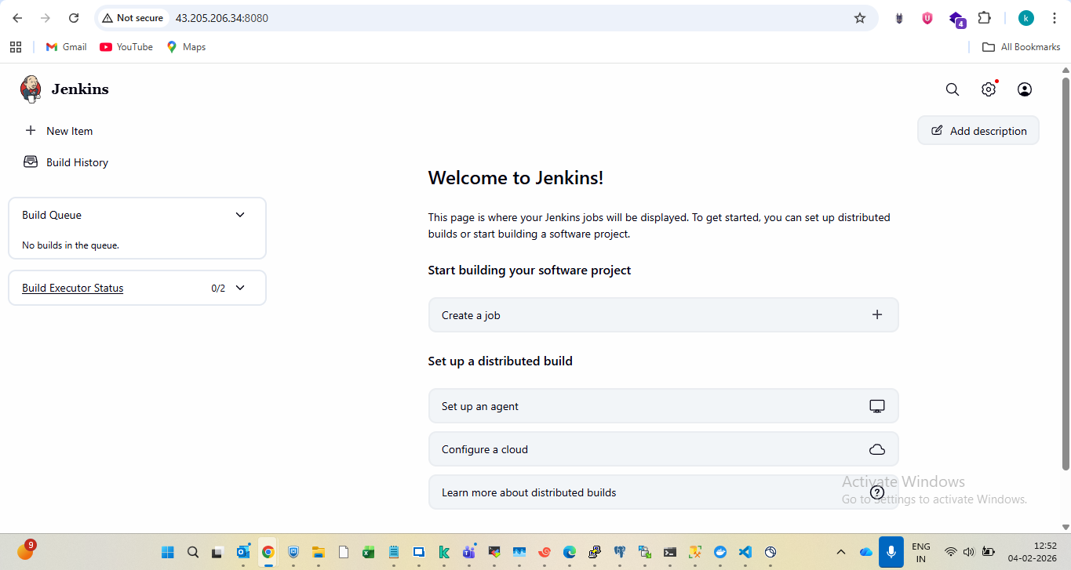
Jenkins
pipeline {
agent any
environment {
DOCKER_IMAGE = "pranathi20222/trend:latest"
}
stages {
stage('Checkout') {
steps {
git branch: 'main', url: 'https://github.com/pranathi2022/Trend_project2.git'
}
}
stage('Build Docker Image') {
steps {
sh 'docker build -t $DOCKER_IMAGE .'
}
}
stage('Push to DockerHub') {
steps {
withDockerRegistry([credentialsId: 'dockerhub-creds', url: 'https://index.docker.io/v1/']) {
sh 'docker push $DOCKER_IMAGE'
}
}
}
stage('Deploy to EKS') {
steps {
sh '''
aws eks update-kubeconfig --region ap-south-1 --name trend-eks
kubectl apply -f deployment.yaml
kubectl apply -f service.yaml
'''
}
}
}
}
Installed required service like Jenkins,docker,git and kubectl
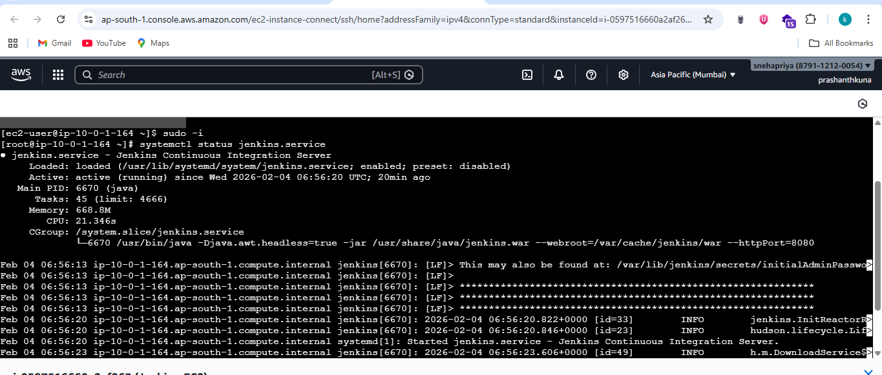
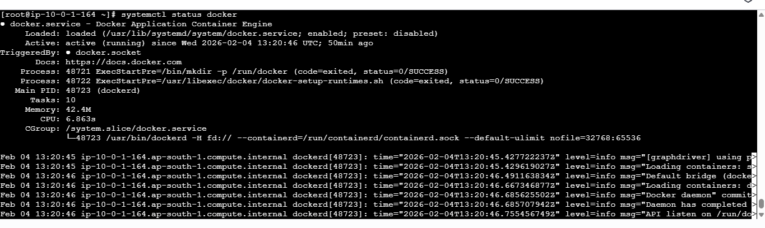
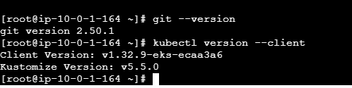
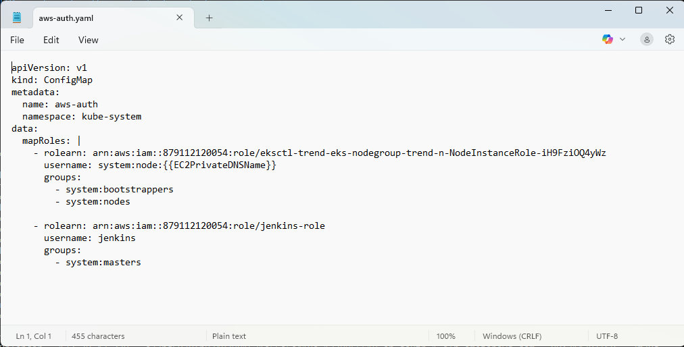
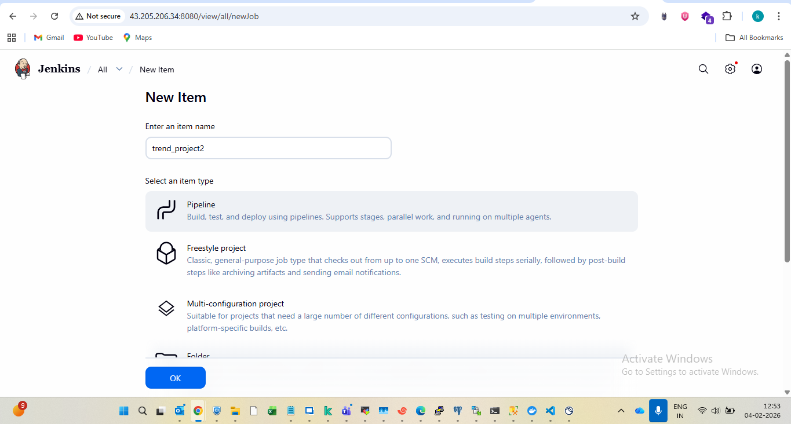
Enabled webhook on Jenkins
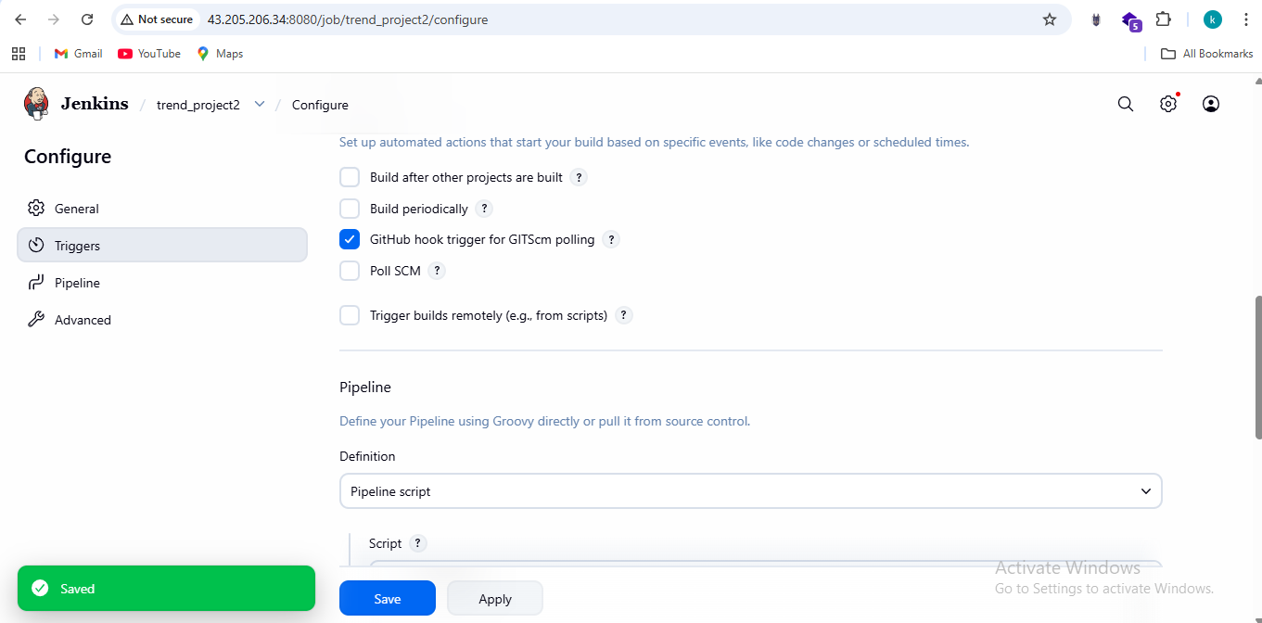

Installed required plugins
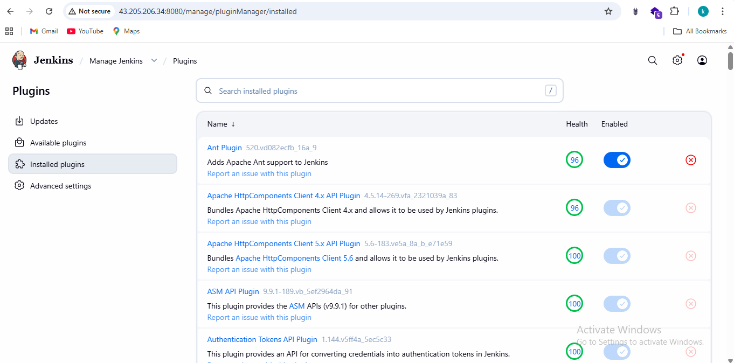
Added docker cred’s
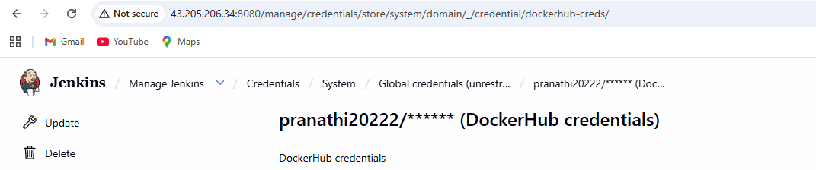
Configured webhook on github
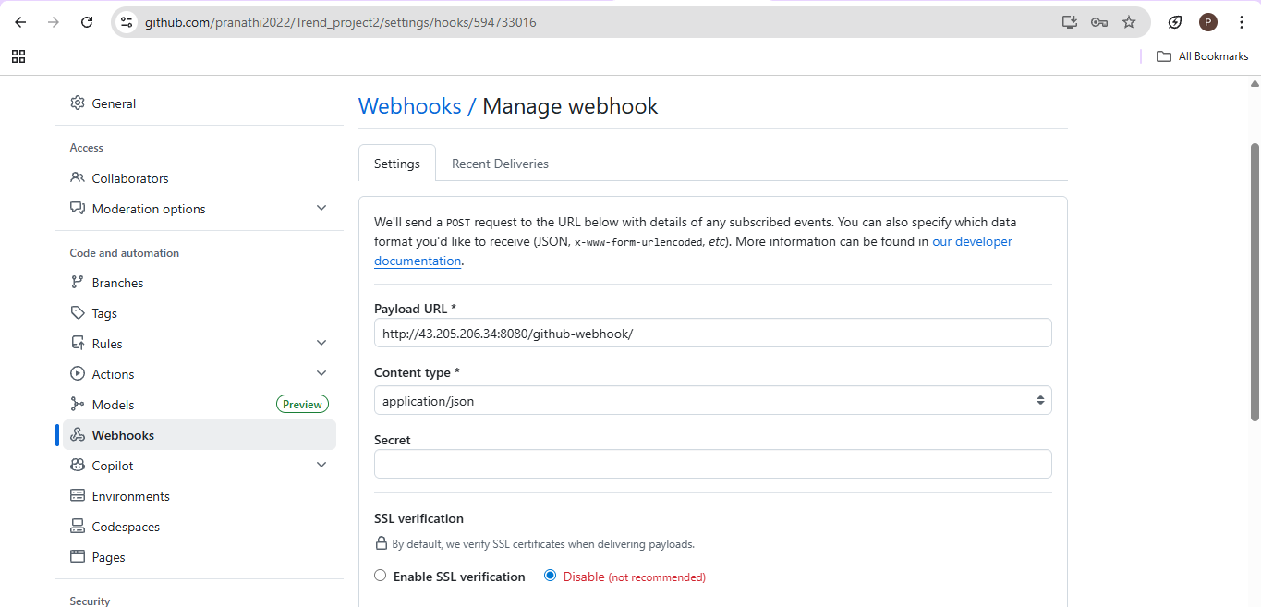
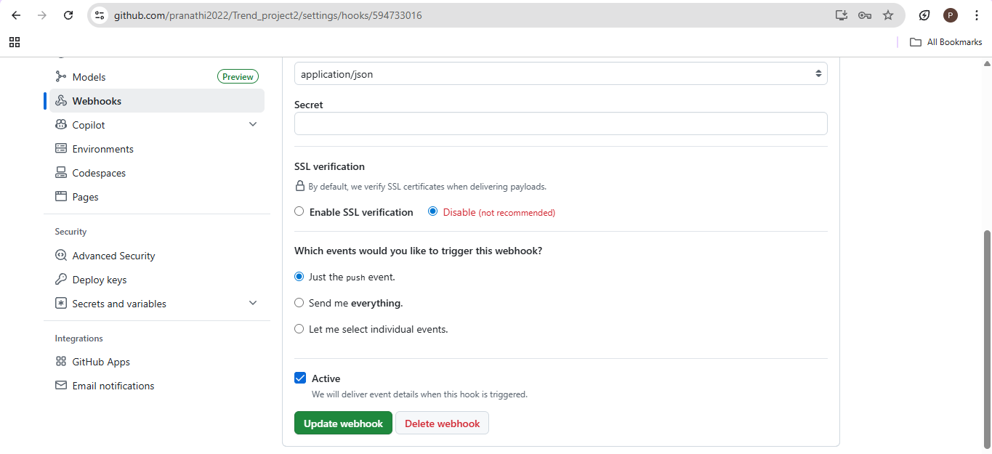

Webhook Triggered
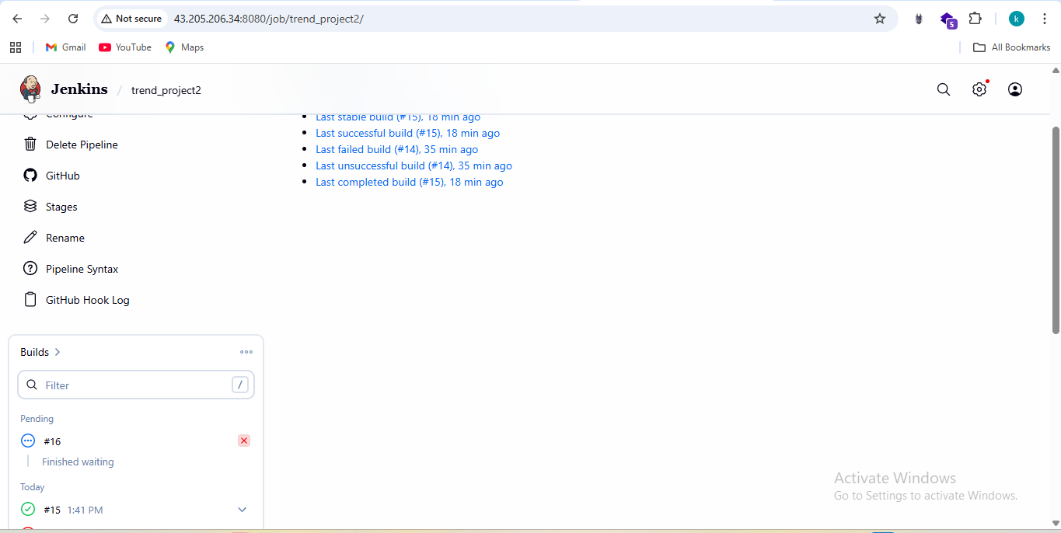
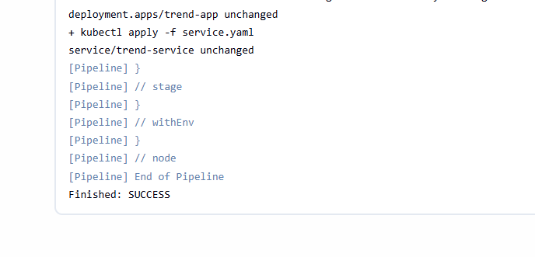

Monitoring
Install Helm
choco install kubernetes-helm -y
helm version
Add Prometheus Helm Repo
helm repo add prometheus-community https://prometheus-community.github.io/helm-charts
helm repo update
Install Prometheus + Grafana Stack
kubectl create namespace monitoring
helm install monitoring prometheus-community/kube-prometheus-stack -n monitoring
Checking pods
kubectl get pods -n monitoring
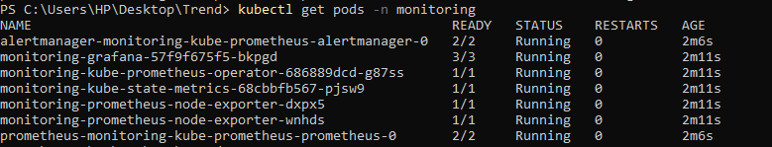
kubectl get svc -n monitoring
kubectl get pods -n monitoring
